**Ideation Phase**

**Define the Problem Statements**

|  |  |
| --- | --- |
| Date | 15 April 2025 |
| Team ID | SWTID1743947156 |
| Project Name | FullStack-Expense-Tracker |
| Maximum Marks | 2 Marks |

**Customer Problem Statement Template:**

Create a problem statement to understand your customer's point of view. The Customer Problem Statement template helps you focus on what matters to create experiences people will love.

A well-articulated customer problem statement allows you and your team to find the ideal solution for the challenges your customers face. Throughout the process, you’ll also be able to empathize with your customers, which helps you better understand how they perceive your product or service.

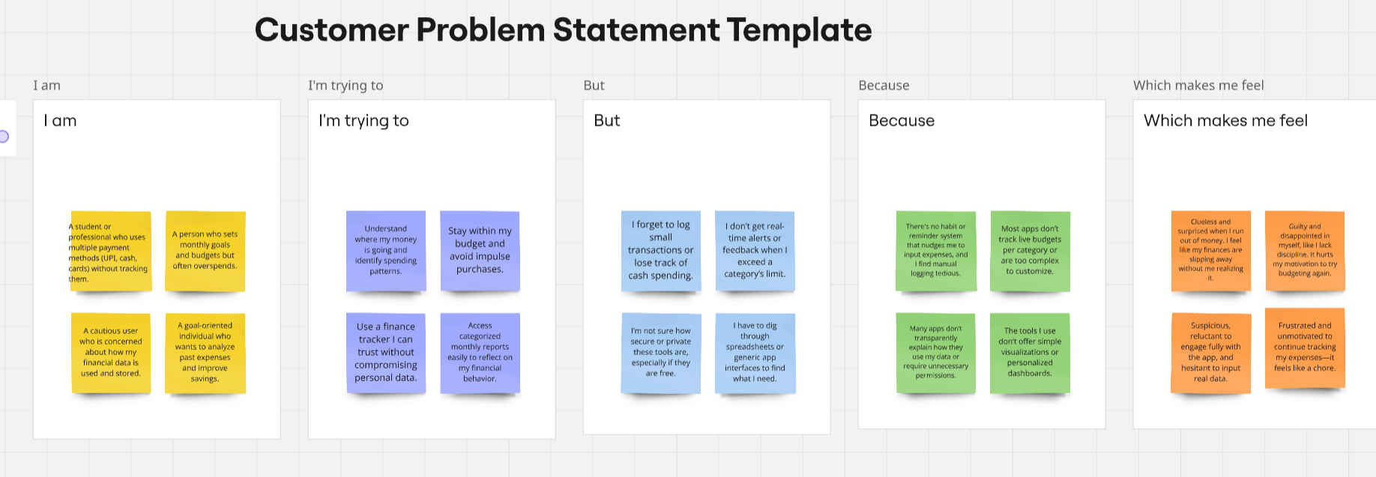

|  |  |  |  |  |  |
| --- | --- | --- | --- | --- | --- |
| **Problem Statement (PS)** | **I am (Customer)** | **I’m trying to** | **But** | **Because** | **Which makes me feel** |
| PS-1 | A student or professional who uses multiple payment methods (UPI, cash, cards) without tracking them. | Understand where my money is going and identify spending patterns. | I forget to log small transactions or lose track of cash spending. | There's no habit or reminder system that nudges me to input expenses, and I find manual logging tedious. | Clueless and surprised when I run out of money. I feel like my finances are slipping away without me realizing it. |
| PS-2 | A person who sets monthly goals and budgets but often overspends. | Stay within my budget and avoid impulse purchases. | I don’t get real-time alerts or feedback when I exceed a category’s limit. | Most apps don’t track live budgets per category or are too complex to customize. | Guilty and disappointed in myself, like I lack discipline. It hurts my motivation to try budgeting again. |
| PS-3 | A cautious user who is concerned about how my financial data is used and stored. | Use a finance tracker I can trust without compromising personal data. | I’m not sure how secure or private these tools are, especially if they are free. | Many apps don’t transparently explain how they use my data or require unnecessary permissions. | Suspicious, reluctant to engage fully with the app, and hesitant to input real data. |
| PS-4 | A goal-oriented individual who wants to analyze past expenses and improve savings. | Access categorized monthly reports easily to reflect on my financial behavior. | I have to dig through spreadsheets or generic app interfaces to find what I need. | The tools I use don’t offer simple visualizations or personalized dashboards. | Frustrated and unmotivated to continue tracking my expenses—it feels like a chore. |